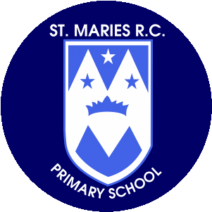+

**Science**

This half term we will be learning about ‘Everyday Materials’. Children will learn to distinguish between a material and an object and will be learning to use words to describe the properties of different objects and materials.

**Mathematics**

Children will be looking at numbers up to 10 and focus on ‘1 more than’ and ‘1less than’ using number lines. We will be sorting and grouping objects up to 10. We will also be using the part whole model within 10 to compare number bonds. We will continue this skill to explore addition and subtraction.

**Art and Design**

**Design Technology**

The children will be investigating ‘Mechanisms wheels and axles’. We will be planning, designing and creating our own vehicles.

**Computing**

The children will be learning how to keep safe on the internet. We will take part in lots of activities that will help them to be safe on their consoles.

**P.S.H.E.**

Through ‘My Happy Mind’, the children will be discovering all about our brains. We will investigate what it looks like an how they help us. We will learn how the brain grows. We will also be meeting the team HAP and how they can help us.

**Religious Education – Come and See**

Children will be looking at the experience of ‘family’ in society today is varied, with many joys and sorrows. We will explore the experience that family still remains the first place for growth and development, the basic social unit. We will also invite children to bring in some photographs of their own families to encourage them to talk about their family, what they do and how they show love and care.

**Year 1**

**Autumn Term 1**

**September - October 2023**

**Music**

Children will use their voices expressively and creatively by singing songs and speaking chants and rhymes. We will also be attending a whole school hymn practice every Tuesday afternoon.

**Thank you for your support.**

**Miss Kirby**

**Homework**

Please encourage your child to read as often as possible and write a comment in their reading record book.

Spellings will be sent home on Fridays for our test the Friday the following week – please encourage your child to learn them. All spellings are also on our class page.

Children also have logins for Oxford Owl and can access books and quizzes for the phonics stage they are working at.

**Physical Education**

P.E. this half term will be on Tuesdays and Thursdays.

We will be focusing on mastering basic movements including running, jumping, throwing and catching, as well as developing balance, agility and co-ordination, and begin to apply these in a range of fun activities.

**English**

The focus for our Steps to Read lessons this half term is stories that look at seasonal changes. ‘Winter Sleep’ by Sean Taylor is the first book that we will look at. For whole class story time we will be reading, ‘The leaf Thief’, written by Alice Hemming, ‘The more it Snows’ a book of poems written by A.A Milne and many more. We will also have Read, Write Inc every day to expand our knowledge of phonics and how to use it to read and write.

**Geography**

Year 1 will be looking at identify seasonal and daily weather patterns in the United Kingdom and the location of hot and cold areas of the world in relation to the Equator and the North and South Poles.