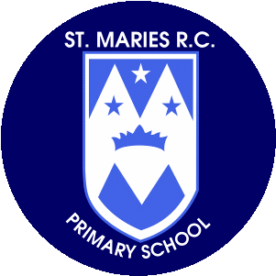

**Computing**

This half term children will develop their understanding of technology and how it can help them in their everyday lives. They will start to become familiar with the different components of a computer by developing their keyboard and mouse skills. we will also consider how to use technology responsibly

**Art and Design**

**Design Technology**

In Art and Design, children will be painting, printing and colour mixing and will explore primary and secondary colours.

* In our DT lessons, children will learn how to keep themselves about fruits and vegetables and where and how they grow. The children will investigate different fruits and vegetables and make their own smoothie.

**English**

The focus for our Steps to Read lessons this half term is stories that are set in our locality. ‘Out and about’ **by Shirley Hughes the first book** that we will look at it is a book of poems and rhymes. The second focus text is ‘the shopping basket’ by John Birmingham it is the story of a boy called Steven who goes on a trip to the shops and meets a lot of interesting characters on the way.

**History**

This half term the children will be History detectives finding out about toys from the past. They will be identifying old and new toys and describing similarities and differences between old and modern toys.

**Religious Education –**

This half term the focus of this branch is to develop an early understanding of the Christian belief that through the ministry of Jesus, some of those who encountered him recognised he was the Son of God.

**Year 1**

**Spring Term**

**January- March**

**Music**

In music children will learn a variety of songs focusing on dynamics, pitch and tempo. They will also learn about a number of instruments and the different ways we can play them.

**Mathematics**

Over the next five weeks, we will be learning about adding and subtracting one-digit and two-digit numbers to 20, including zero. We will solve problems that involve addition and subtraction, using objects and pictures, and missing number problems such as 7 = ☐ – 9.

Later on in the half term, we will be counting, reading and writing numbers to 50.

**Thank you for your support.**

**Miss Kirby**

**Science**

This half term the children will be looking at plants. They will look at the different parts of a plant and learn the names of some common plants and tress.

**Homework**

Please encourage your child to read as often as possible and write a comment in their reading record book.

Spellings will be sent home on Mondays for our test the Friday– please encourage your child to learn them. All spellings are also on our class page.

Children also have logins for Oxford Owl and can access books and quizzes for the phonics stage they are working at.

**Physical Education**

PE is on a Tuesday and Thursday children can come to school wearing their kits. We will be focusing lessons on striking and fielding skills. Children will learn how to be part of a team and the tactics involved.

**Geography**

Year 1 will be looking at the United Kingdom and a country on each of the seven continents and exploring their features, people and landmarks. We will also be learning where the seven continents are on a map and will be doing a variety of fun activities to help us learn more about each one.