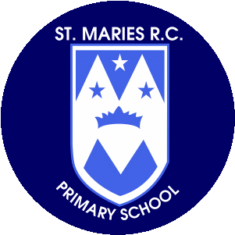

**Art and Design**

In Art and Design, children will be painting, printing and colour mixing and will explore primary and secondary colours.

**Science**

This half term the children will continue to look at plants. They will take a closer look at the different parts of a plant and learn the names of some common plants and trees. Children will examine the different species of trees .

**Religious Education – To know you more clearly**

Branch 5 Revelation, children will explore the different ways in which revelation is experienced, beginning with revelation through Creation, then moving on to revelation in the incarnation of Jesus.

**Physical Education**

In PE this term children will learn skills in gymnastics and dance. Children will learn different balances and jumps. They will learn how to use apparatus safely and start to create sequences and routines using their new skills. Our PE days will continue to be Tuesday and Thursday.

**Mathematics**

In mathematics this term children will solve one-step problems involving multiplication and division, by calculating the answer using concrete objects, pictorial representations and arrays. They will investigate recognise, find and name a half as one of two equal parts of an object, shape or quantity. Children will begin to recognise, find and name a quarter as one of four equal parts of an object, shape or quantity.

**Computing**

In computing this term, the children will use bee bots to investigate programming. They will also have an introduction to data.

Throughout the term children will be taught how to keep safe online.

**P.S.H.E.**

We are looking at ‘engage’ over the next few weeks. Children will learn when they feel good, they do good. They will learn that setting goals is a good way to achieve what they want; children will learn the 3 steps to setting a goal and practice setting goals as a class.

**Music**

This half term the musical focus will be Active listening (musical signals, internalising beat, draw to music, movement/actions), electronic music. The topic the children will gain these skills within is called ‘Drawing and dancing to Nautilus’.

**Homework**

Please encourage your child to read as often as possible and write a comment in their reading record book.

Children also have logins for Oxford Owl and can access books and quizzes for the phonics stage they are working at.

**Year 1**

**Summer Term**

**April- May 2024**

**Thank you for your support.**

**Miss Kirby and Miss Vaughan**

**English**

The focus for our Steps to Read lessons this half term is ‘Winter Sleep a hibernation story’ Sean Taylor partners with ecologist Alex Morss and illustrator Cinyee Chiu to create the text for this quiet, enticing walk into the natural world. The pictures work alongside the rich, poetic language to create a sense of awe, wonder and joy in the natural world.

**Geography**

Year 1 will be investigating Antarctica with a focus on the weather and climate. They will gain an understanding about the equator and how the proximity of a country to the equator will have an effect on the environment and humidity.